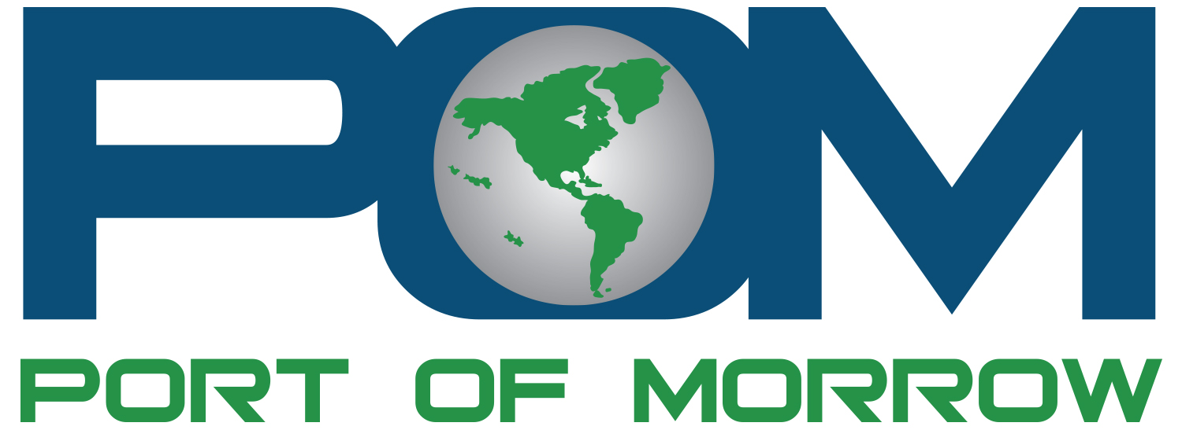

POSITION DESCRIPTION
MARKER 40 GOLF CLUB

Open: January 1, 2023
Duration: Summer 2023
Job Title: Golf Attendant Internship
Supervisor: Superintendent
Employment Status: Full time, exempt
Regular Hours: 40 hours per week

Overall purpose and objective of this position:
The Port of Morrow is offering an entry level golf attendant internship for Marker 40 Golf Club that will introduce the intern to a wide variety of projects and on-site job skills.

WORK DESCIRPTION:
Responsible for assisting the Course Superintendent and Clubhouse Manager with the day-to-day operations of the golf course and clubhouse. Compensation: $17.65/hr

ESSENTIAL FUNCTIONS/MAJOR RESPONSIBILITIES:
- Properly mows greens, operates tractor, assists with landscaping, bunker maintenance, and repairs divots.
- Coordinate activities of players from check-in to the first tee, collecting green fees, assigning golf carts, club rentals, merchandise sales.
- Upkeep of the golf course’s cart fleet. Perform light cleaning and restocking of merchandise in the golf shop.
- Accurately reconciles cash register sales with daily sales reports. Open and closes golf shop when scheduled.
- Enhance the overall golf experience for Club members & guests through friendly courteous service in person and over the phone.
- The Golf Course Attendant will also be assigned specific, often varying tasks on a day-to-day basis by the clubhouse manager or course superintendent.
- Performs other related duties as needed and/or assigned. Is proactive to make sure facility is always clean and safe.
- Ability to work a flexible schedule that will include evenings, weekends, and holidays.
- Have or be willing to obtain an OLCC license

ENVIRONMENTAL FACTORS:
Work is mainly outside thus exposed to various weather conditions.

Application Process
Application materials required no later than April 1, 2023.

- Application
- Resume
- Letter of Interest

