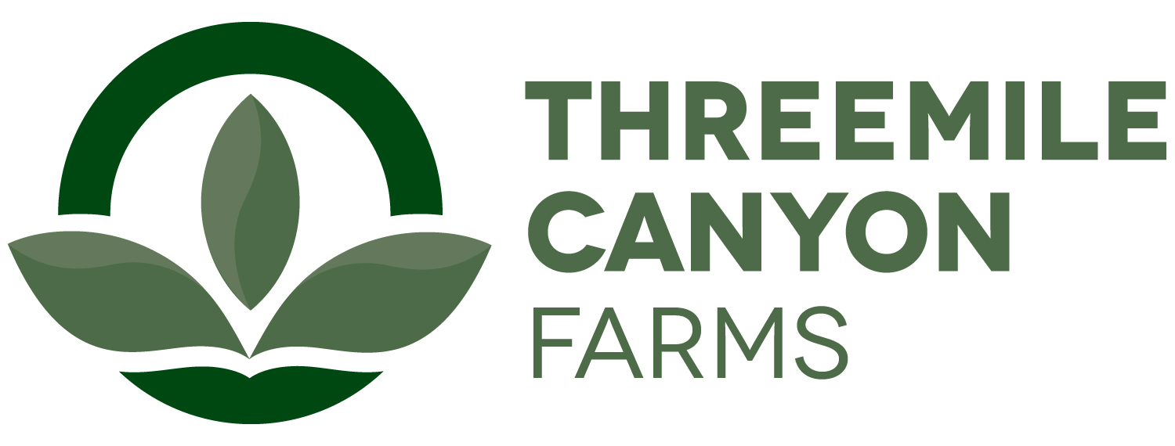

Accounting Internship
Boardman, OR

Threemile Canyon Farms Accounting internship offers a variety of opportunities to learn accounting and finance principle in a complex organization. Below you will find a list of operations that are involved in the accounting department:
- Analyzes trends, costs, revenues, financial commitments/obligations, and assist with accruals
- Assist with accounting duties such as accounts payable and receivable, invoice processing, data tracking
- Assist in the preparation of balance sheets, profit and loss statements, and other financial reports.
- Performs special projects and ad-hoc duties as assigned
- Assist in preparing monthly journal entries and help to ensure a timely and accurate close process
- General ledger activities including but not limited to fixed assets and related depreciation schedules, notes payable, inventory, prepaids, investments and cost allocations

The internship will require at least 8 weeks with the option for additional internship work experience. Internships start dates are flexible and depend on the student’s academic calendar. The intern will be paid $12.50/hr. Upon successful completion of the internship, the student will also receive a $10,000 scholarship toward his or her education. In general, interns will be expected to work 40+hrs/week and occasional weekend work. Housing may be provided depending on availability.

A recognized leader in sustainable agriculture, Threemile Canyon Farms combines dairy operations with conventional and organic crop farming to create a closed-loop system where nothing is wasted. Our zero-waste, values-driven operations reflect our commitment to protecting the environment, caring for our animals, and supporting our community. In 2020, Threemile received the Innovation Center for U.S. Dairy’s award for Outstanding Dairy Sustainability and was also the first dairy to earn a 100% score on the Validus independent animal welfare audit. With more than 300 full-time and 150 seasonal team members, we support a strong, sustainable food supply for our community and the country.

To apply, please submit the following in printed form:
- A one-page letter summarizing your experience and reasons for interest in the internship, including a statement of future career goals.
- A resume.
- Summary of animal and dairy science courses taken, and grades earned in each.
- Two letters of recommendation, one from a faculty member who knows you well and one from another faculty member or a past employer.

Ann Hauff
HR Manager
ahauff@rdoffutt.com
701-526-9814

