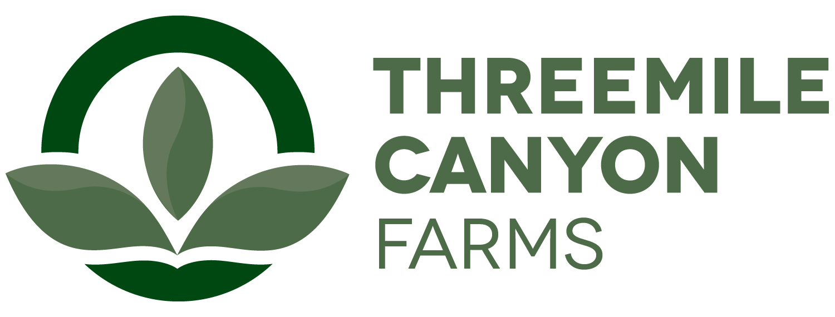

Dairy Internship
Boardman, OR

Threemile Canyon Farms is pleased to announce a hands-on dairy internship experience. We milk over 35,000 cows and raise dairy heifers and steers on site. The interns will work in all the major dairy departments: reproduction, milking, breeding, maternity, herd management, and the heifer raising facility. The main aim is for the interns to become familiar with all the major areas of dairy management by participating in the day-to-day work of the departments. The student will learn the systems used to manage cattle, maintain productivity, and prevent disease on a large facility. The interns will be working closely with the supervisor in each area and with the herd managers and veterinarians. The interns will be asked to participate in a project, collecting data to help improve management in each area. The project will be designed to accommodate both the needs of the farm and the interests of the student.

The internship will require at least 8 weeks with the option for additional internship work experience. Internships start dates are flexible and depend on the student’s academic calendar. The intern will be paid $12.50/hr. Upon successful completion of the internship, the student will also receive a $10,000 scholarship toward his or her education. In general, interns will be expected to work 55-60h/week. Housing may be provided depending on availability.
Preference will be given to students with demonstrated interest in a dairy industry career and who seek practical on-farm experience. Ability to speak Spanish is preferred.

A recognized leader in sustainable agriculture, Threemile Canyon Farms combines dairy operations with conventional and organic crop farming to create a closed-loop system where nothing is wasted. Our zero-waste, values-driven operations reflect our commitment to protecting the environment, caring for our animals, and supporting our community. In 2020, Threemile received the Innovation Center for U.S. Dairy’s award for Outstanding Dairy Sustainability and was also the first dairy to earn a 100% score on the Validus independent animal welfare audit. With more than 300 full-time and 150 seasonal team members, we support a strong, sustainable food supply for our community and the country.

To apply, please submit the following in printed form:
- A one-page letter summarizing your experience and reasons for interest in the internship, including a statement of future career goals.
- A resume.
- Summary of animal and dairy science courses taken, and grades earned in each.
- Two letters of recommendation, one from a faculty member who knows you well and one from another faculty member or a past employer.

Ann Hauff
HR Manager
ahauff@rdoffutt.com
701-526-9814

