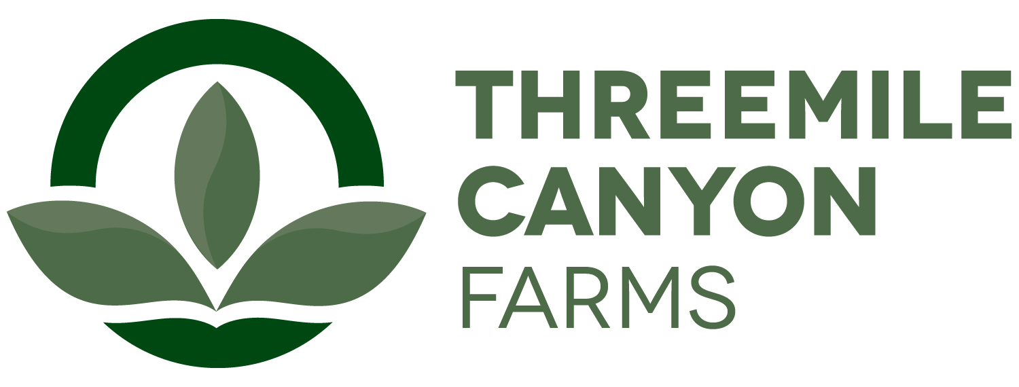

Digestor Safety Internship
Boardman, OR

Threemile Canyon Farms Digestor Safety internship offers a variety of opportunities to learn the functions and work procedures. Below you will find a list of operations that are involved in digestor department.
- Creating standard operating procedures for each job task and work procedure.
- Create job hazard analysis and job safety analysis
- Work with manager, technician, operator, and mechanics on projects.
- Assist RNG Administration with filling, record keeping, inventory and preventative maintenance written procedures.

We are located about 150 miles East of Portland, just off the Threemile exit on I-84. Boardman and Arlington, Oregon are the closest towns. More information about our communities can be found on our website at www.threemilecanyonfarms.com as well as our local chamber website at www.boardmanchamber.org.

The internship will require at least 8 weeks with the option for additional internship work experience. Internships start dates are flexible and depend on the student’s academic calendar. The intern will be paid $12.50/hr. Upon successful completion of the internship, the student will also receive a $10,000 scholarship toward his or her education. In general, interns will be expected to work 50+hrs/week and occasional weekend work. Housing may be provided depending on availability.

To apply, please submit the following in printed form:
- A one-page letter summarizing your experience and reasons for interest in the internship, including a statement of future career goals.
- A resume.
- Summary of animal and dairy science courses taken, and grades earned in each.
- Two letters of recommendation, one from a faculty member who knows you well and one from another faculty member or a past employer.

Ann Hauff
HR Manager
ahauff@rdoffutt.com
701-526-9814

