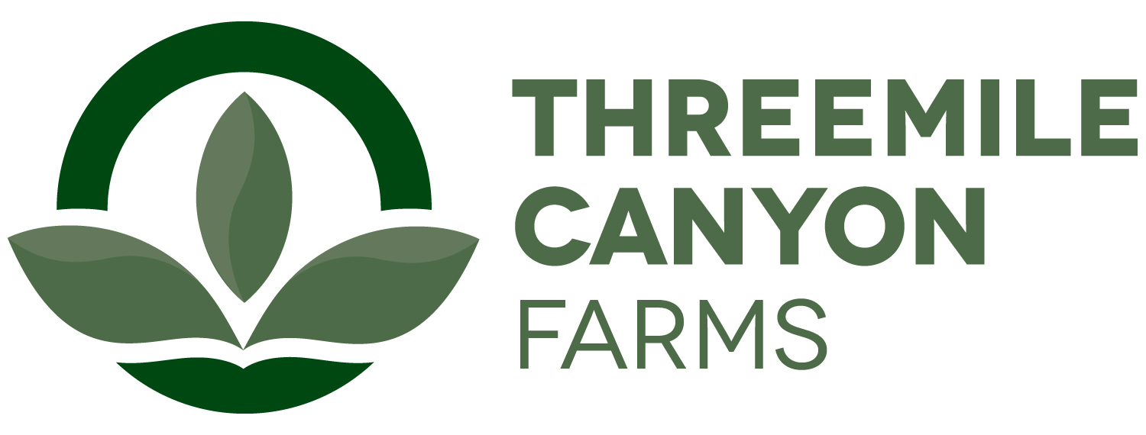

Mechanic Internship
Boardman, OR

Threemile Canyon Farms is pleased to announce a hands-on farming internship experience. Our farm consists of 460 center pivots equaling about 52,726.1 irrigated acres near the Columbia River. To keep up with planting, harvesting as well as the dairy operations we maintain a large fleet of equipment. Interns will have the opportunity perform basic diagnosis, adjustments, repair, and maintenance in shop or fields to some equipment at a high level of quality with conformance to efficiency standards in a timely manner. Operate basic dairy and farm equipment, orders parts and materials for performing maintenance and repairs. Pays close attention to detail and displays a willingness to continue learning.

The internship will require at least 8 weeks with the option for additional internship work experience. Internships start dates are flexible and depend on the student’s academic calendar. The intern will be paid $12.50/hr. Upon successful completion of the internship, the student will also receive a $10,000 scholarship toward his or her education. In general, interns will be expected to work 50+hrs/week and occasional weekend work. Housing may be provided depending on availability.

A recognized leader in sustainable agriculture, Threemile Canyon Farms combines dairy operations with conventional and organic crop farming to create a closed-loop system where nothing is wasted. Our zero-waste, values-driven operations reflect our commitment to protecting the environment, caring for our animals, and supporting our community. In 2020, Threemile received the Innovation Center for U.S. Dairy’s award for Outstanding Dairy Sustainability and was also the first dairy to earn a 100% score on the Validus independent animal welfare audit. With more than 300 full-time and 150 seasonal team members, we support a strong, sustainable food supply for our community and the country.

To apply, please submit the following in printed form:
- A one-page letter summarizing your experience and reasons for interest in the internship, including a statement of future career goals.
- A resume.
- Summary of animal and dairy science courses taken, and grades earned in each.
- Two letters of recommendation, one from a faculty member who knows you well and one from another faculty member or a past employer.

Ann Hauff
HR Manager
ahauff@rdoffutt.com
701-526-9814

