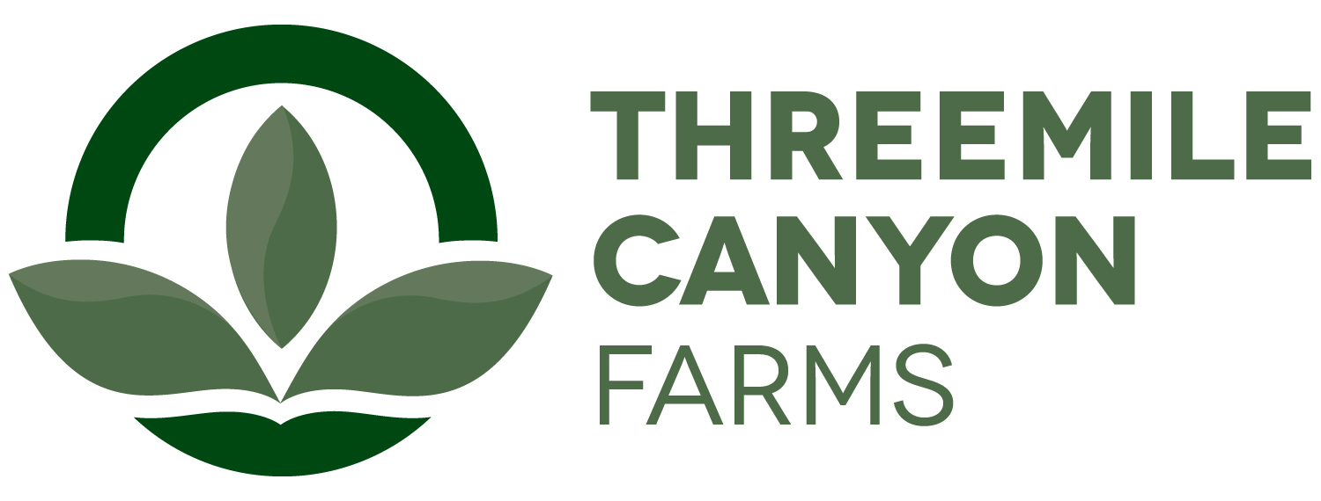

Irrigation Internship
Boardman, OR

Threemile Canyon Farms is pleased to announce a hands-on farming internship experience. Our farms consist of 460 center pivots equaling about 52,726.1 irrigated acres. There is a variety of opportunities in the irrigation internship program. Below you will find a list of operations that are involved in the irrigation department, and it will be up to the intern and the intern’s interest of what path they choose. Interns may choose multiple operations and/or be asked to do multiple operations.
- Irrigation System Operator
- Welder
- Computer Programming
- Network Engineering
- Industrial Automation
- Low Voltage Electrical work
- Pump Maintenance
- Pipe System Design
- Solid Modeling
We are located about 150 miles East of Portland, just off the Threemile exit on I-84. Boardman and Arlington, Oregon are the closest towns. More information about our communities can be found on our website at www.threemilecanyonfarms.com as well as our local chamber website at www.boardmanchamber.org.

Near the end of the internship the individual will be tasked with a specific project that falls into one of the above categories. The project will be directed by the Irrigation manager or IT manager and must be complete by the end of the internship.
The internship will require at least 8 weeks with the option for additional internship work experience. Internships start dates are flexible and depend on the student’s academic calendar. The intern will be paid $12.50/hr. Upon successful completion of the internship, the student will also receive a $10,000 scholarship toward his or her education. In general, interns will be expected to work 50+hrs/week and occasional weekend work. Housing may be provided depending on availability.
A recognized leader in sustainable agriculture, Threemile Canyon Farms combines dairy operations with conventional and organic crop farming to create a closed-loop system where nothing is wasted. Our zero-waste, values-driven operations reflect our commitment to protecting the environment, caring for our animals, and supporting our community. In 2020, Threemile received the Innovation Center for U.S. Dairy’s award for Outstanding Dairy Sustainability and was also the first dairy to earn a 100% score on the Validus independent animal welfare audit. With more than 300 full-time and 150 seasonal team members, we support a strong, sustainable food supply for our community and the country.

To apply, please submit the following in printed form:
- A one-page letter summarizing your experience and reasons for interest in the internship, including a statement of future career goals.
- A resume
- Summary of animal and dairy science courses taken, and grades earned in each.
- Two letters of recommendation, one from a faculty member who knows you well and one from another faculty member or a past employer.

Ann Hauff
HR Manager
ahauff@rdoffutt.com
701-526-9814

